# **FOOD ORDERING SITE**

### **A MINI PROJECT REPORT**

#### **Submitted by**

#### **Group/Team No: G21/T4**

**Members:**

**ARYAN SONKAR 2210990182**

**ARYAN WALIA 2210990185**

**ASHISH KARAKOTI 2210990186**

**ASHISH RANA 2210990187**

#### **in partial fulfillment for the award of the**

***degree of***

## **BACHELEOR OF ENGINEERING**

***in***

COMPUTER SCIENCE & ENGINEERING



**CHITKARA UNIVERSITY**

**CHANDIGARH-PATIALA NATIONAL HIGHWAY**

**RAJPURA (PATIALA) PUNJAB-140401 (INDIA)**

APRIL 2023

###### TABLE OF CONTENTS

|  |  |  |
| --- | --- | --- |
| **Sr.no** | **Section** | **Page****no** |
| 1 | Introduction | 1 |
| 2 | Problem Statement | 2 |
| 3 | Technical Details | 3 |
| 4 | Key Features | 4 |
| 5 | Project Highlights | 5-8 |
| 6 | Bonus Feature | 9 |
| 7 | Conclusion | 10 |
| 8 | Future Aspects | 11 |
| 9 | References/Links | 12 |

**1.)Introduction**

**Title : Food Ordering Site**

**Purpose And Goals**

In this site, a person can choose from available food items based on various unique and mouthwatering dishes available in menu . An online payment gateway method and bill is generated. Each and every food items has corresponding description and price details . In order to create a smooth and efficient food ordering experience for customers and owners while providing transparency and convenience in payment processing and providing them with access to easily navigate through all sorts of items available.

**About**

* + 1. **Site Name :**"Graphinos”

**1.2.2 Project Members**

**Group/Team No:** G21/T4

**Members** :

* ARYAN SONKAR 2210990182
* ARYAN WALIA 2210990185
* ASHISH KARAKOTI 2210990186
* ASHISH RANA 2210990187

**2.)Problem Statement**

The online food ordering system sets up a food menu online and customers can easily place order as per they like. Also, the online customers can easily track their orders. The management maintain customers database , and improve food delivery service. This system also provides a feedback system in which user can rate the food items .

Also the proposed system can recommend hotels, food, based on the ratings given by the customer, the hotel staff will be informed for the improvements along with quality. The payment can be made online or cash or pay-on-delivery system. For more secured ordering, separate accounts are maintained for each user by providing them with an id and password. Overall, the site provides a smooth and efficient food ordering experience for both customers and sellers, providing transparency, convenience and reliability in the ordering and payment process. Moreover it is a simple food ordering site developed using html, css and javascript with a user and admin side.

**3.)Technical Details**

**3.1 Worskspace/Editor**

**3.1.1 Vs Code**

Visual Studio Code is a versatile code editor that supports HTML and CSS. It offers several features and extensions to streamline the coding process, including autocompletion, formatting, linting, and debugging tools. With VS Code, developers can write and preview their code in real-time, making it the best tool for web development using HTML and CSS.

**3.2 Languages used**

**3.2.1 HTML**

HTML (Hypertext Markup Language) is a markup language used to create the structure and content of web pages. Used to determine page layout, headers, paragraphs, images, links, forms and other page elements when creating an order page. HTML forms the basis of web development and is an essential part of any website.

**3.2.2 CSS**

CSS (Cascading Style Sheets) is a style sheet language used to design the visual appearance of web pages. To add color, font, layout and other design elements to the HTML structure used to create the feed order page. CSS allows developers to create responsive and attractive websites that adapt to different devices and screen sizes.

**3.2.3 Javascript**

JavaScript is a scripting language used to add interactivity and functionality to web pages. It was not explicitly mentioned in the initial request, but it was necessary to create a functional and dynamic food ordering site. JavaScript is used to handle user events,forms, payments,interact with databases.This allows to create interactive and responsive websites.

**4.)Key Features**

Some of the key features of this food ordering website project are:

**1.)User-friendly interface**: The site has an intuitive and easy-to-use interface that allows users to browse the menu, select items and place orders quickly.

**2.)Displayable Menu Card**: This feature enables the user to get a proper menu card with each categorization for separate food types such as Indian , Western ,Chinese with further subdivisions regarding breakfast ,lunch , brunch, dinner and all. This feature is a time saver as the customer need not go through each item list and can select his priority.

**3.)Efficient Order Management**: The site provides an easy platform to manage orders and payments, optimize menus and processes, and improve the efficiency of ordering food for restaurants and vendors.

**5.)Complete billing history**: The site provides a complete billing information, including fixed billing, tax calculations and payment details, to ensure customers have an accurate understanding of order costs.

**6.)Customizable menu options:** The site allows restaurants and vendors to customize menu options and update them as per avaliabilty of products and as per time of today such as specific items for only breakfast etc.

**7.)Responsive design**: Responsive website design is adapted to different devices and screen sizes, making it accessible and easy to use on desktop and mobile devices according to the size of the electronic gadget used.

Overall, the site provides a smooth and efficient food ordering experience for both customers and sellers, providing transparency, convenience and reliability in the ordering and payment process

**5.)Project Highlights**

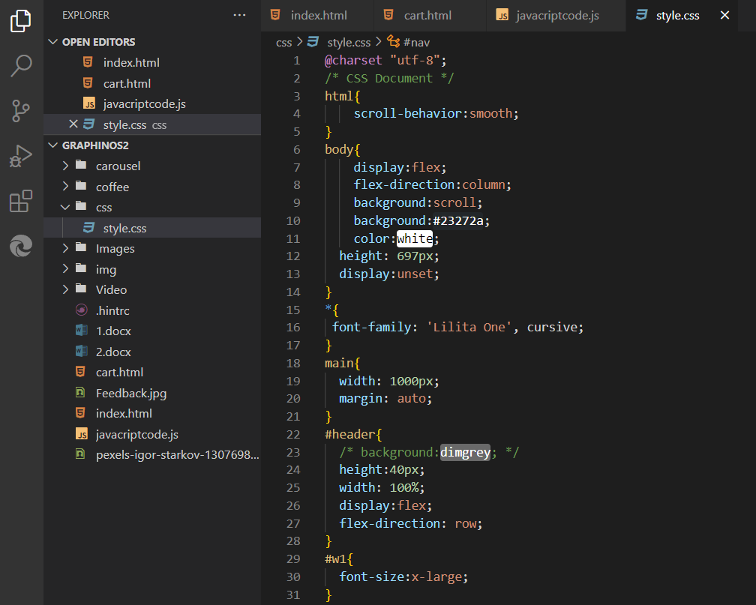

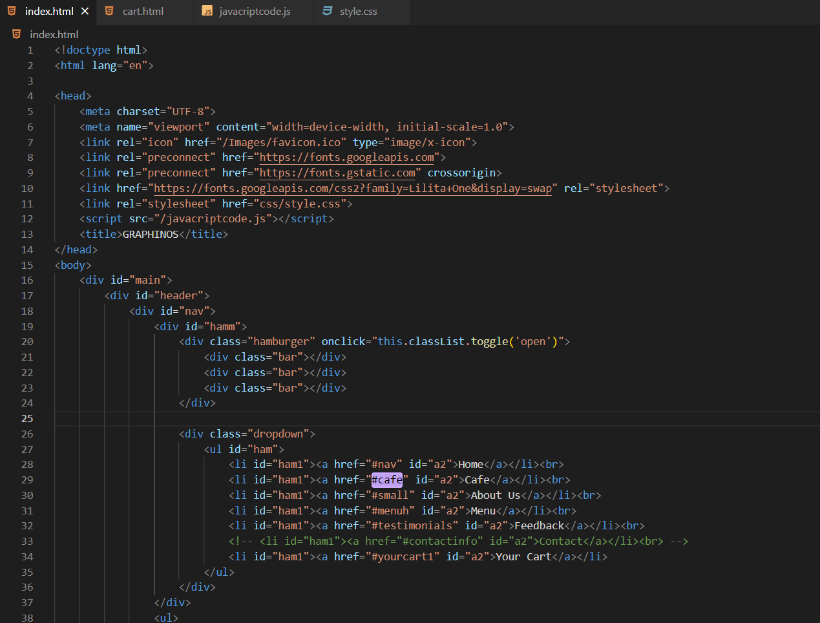

**CSS Snippet                                      HTML Snippet**

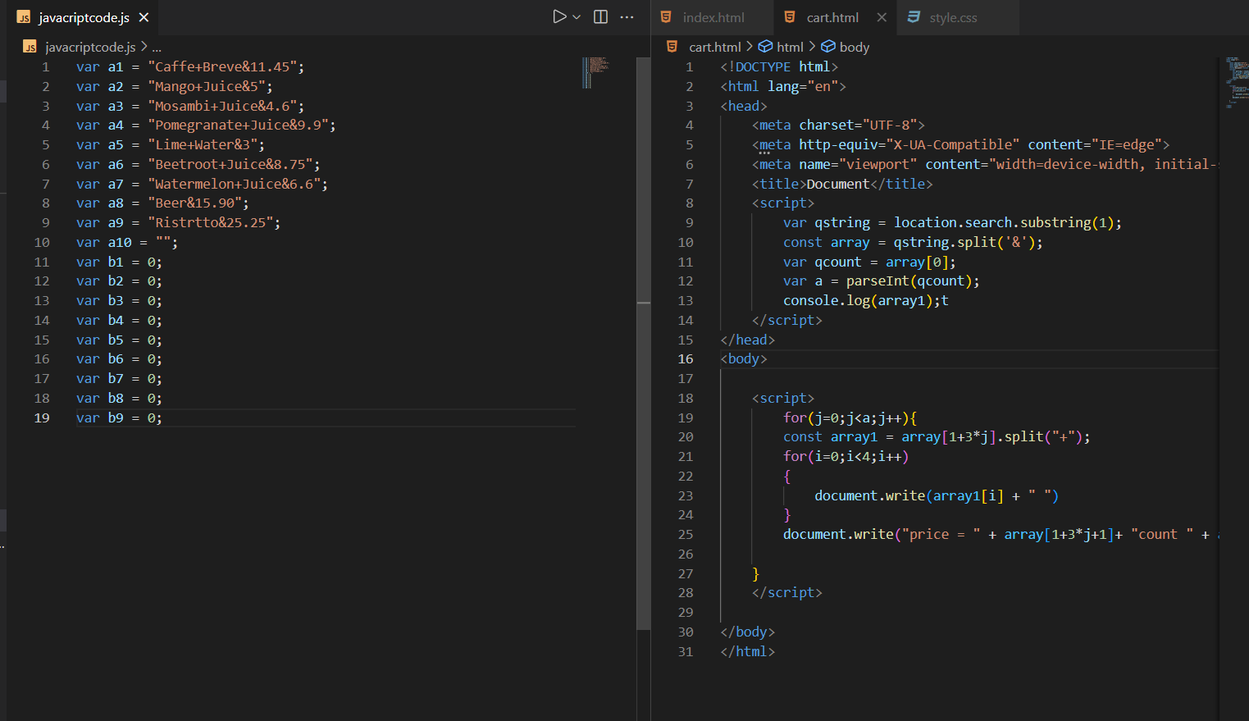

**JavaScript Snippet**

**JavaScript Snippet**

1. **Index Page – Screen Shot 1**

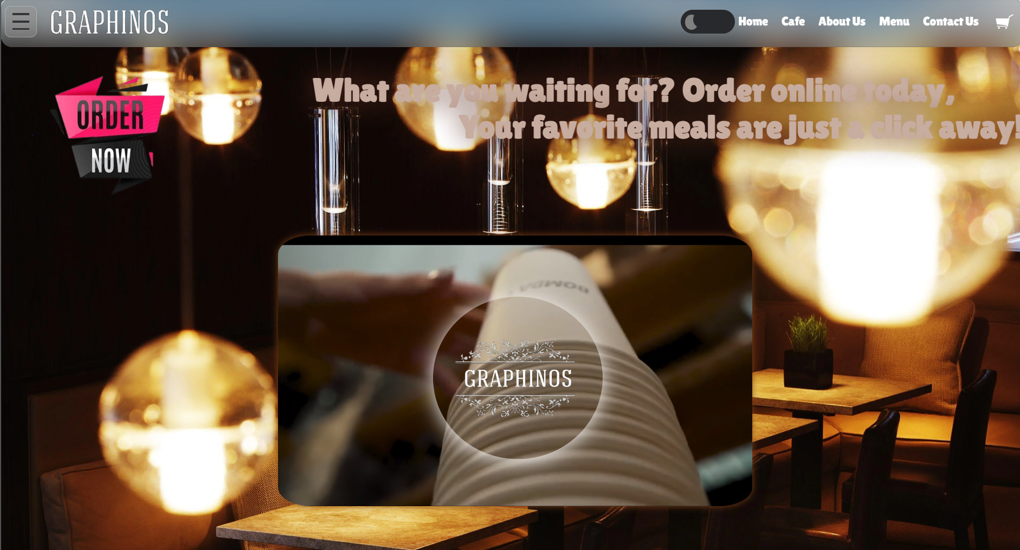

1. **Index Page – Screen Shot 2**

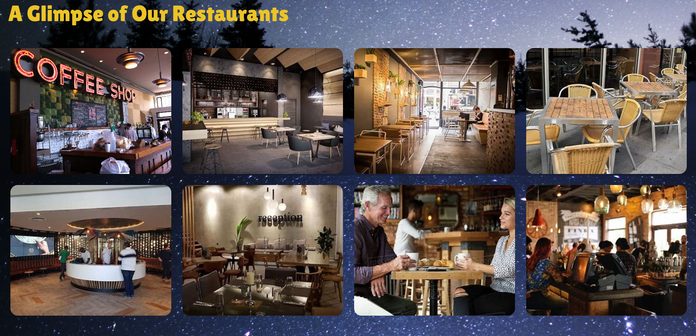

1. **Index Page – Screen Shot 3**

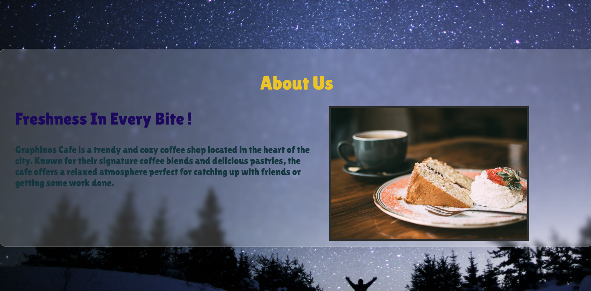

1. **Index Page – Screen Shot 4**

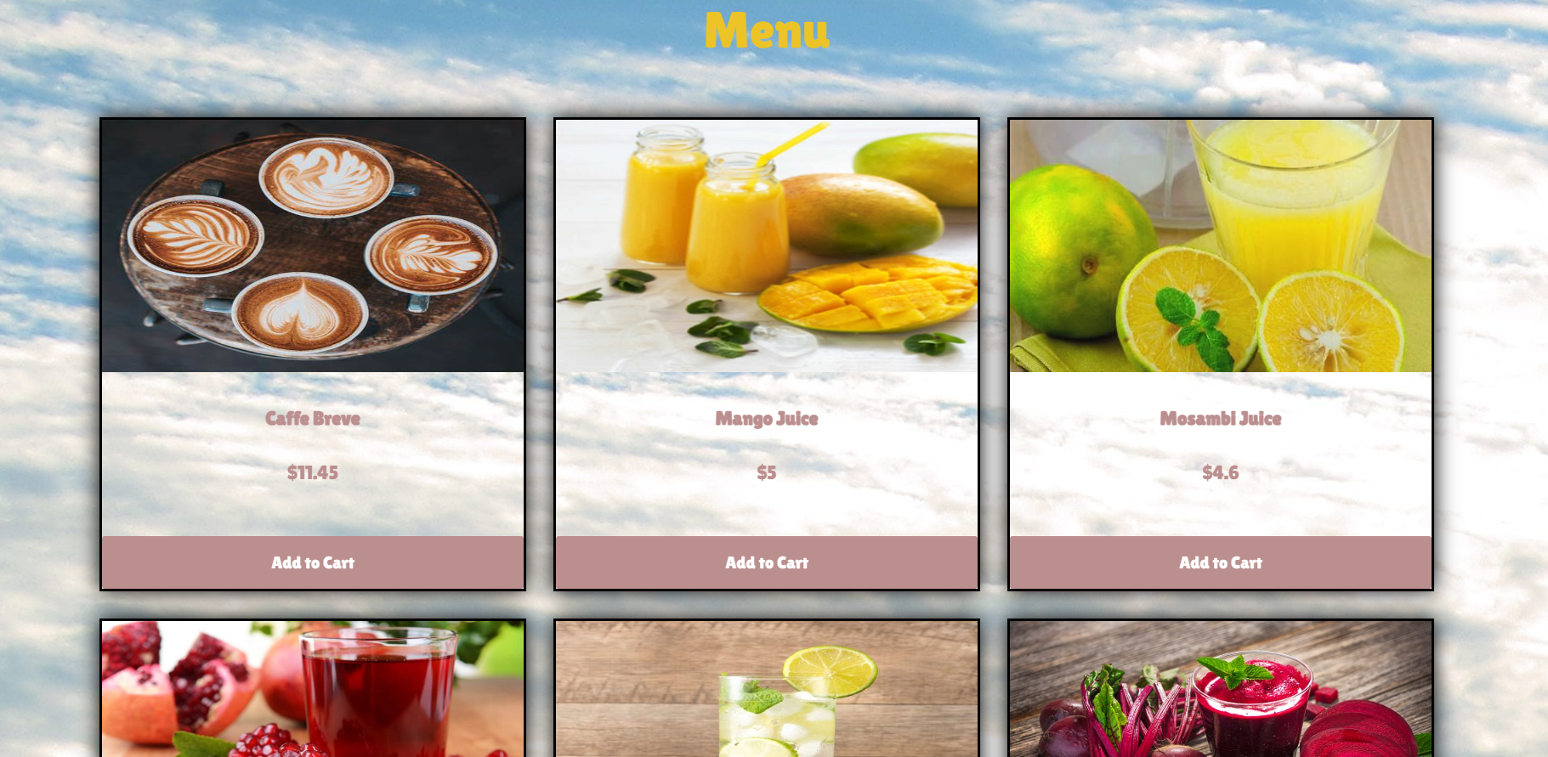

1. **Index Page – Screen Shot 5**

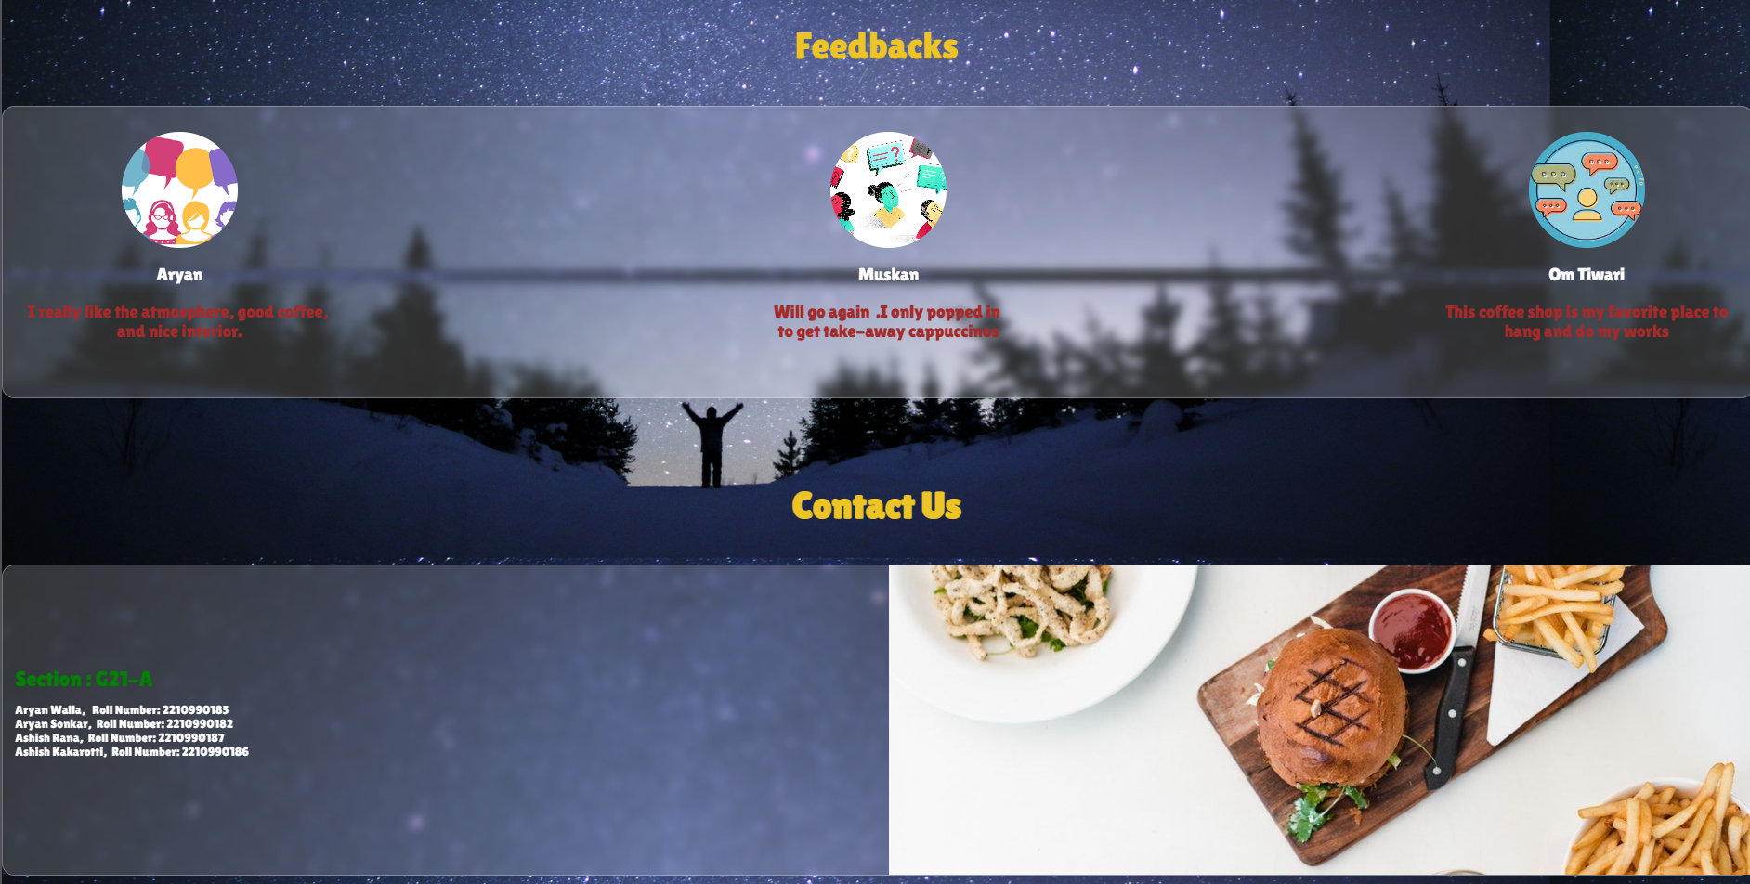

**6.)Bonus Features**

* **Day and Night mode :**

A switch button that changes the theme of the site located in the navbar itself. And available throughout.

* **Hamburger Menu button :**

A dropdown button which on interaction showcases the accessible option for the user to navigate through the site.

* **Feedback analogue :**

Every business cares for its customers as they’re the ones who ultimately buy products or services . Hence , it’s important that your app meets the user needs or not.Reviews and ratings

**7.)Conclusion**

**Key points of the project:**

1. Various payment modes
2. Easy and proper order management
3. Displayable menu card/options
4. Complete billing information
5. User friendly interface
6. Responsive design

**Bonus features you can add:**

1. Day and Night button
2. Your Cart & Dropdown Hamburger Button.

**Key takeaways for the team from the experience:**

**\*** The importance of effective communication and coordination between team members.

**\*** Attention to each feature in detail.

**\*** The importance of user testing , reviews and ratings, feedback form.

**\*** Technical aspects and details of web development (HTML, CSS, JavaScript).

**\*** Project management skills (straight-forward objectives, deadlines, resource management).

**\*** Testing and quality assurance.

Overall, the team had valuable skills , techniques and experience in web development , project

making , and user experience design while creating a valuable and user-friendly food ordering

site that meets the needs of customers and users.It was a great learning experience with several

ups and downs . We stepped into a new field of web development which is an excellent field if

explored well.

**8. Future Aspects**

* **Enhanced Personalization:** Food ordering sites will leverage advanced algorithms and machine learning to provide highly personalized recommendations based on user preferences, dietary restrictions, and past ordering history. This will ensure a more tailored and enjoyable experience for customers.
* **Social Integration:** Food ordering sites will incorporate social media features, allowing users to share their favorite dishes, leave reviews, and engage with other food enthusiasts. This social integration will create a vibrant community and foster a sense of connection among users.
* **Gamification and Rewards:** To increase customer engagement and loyalty, food ordering sites may incorporate gamification elements and reward systems. Users can earn points, badges, or discounts for completing challenges, referring friends, or ordering from specific restaurants. This gamified experience will add an element of fun and incentivize repeat business.

**9.)References/links used**

* <https://www.w3schools.com/html/>
* https://www.geeksforgeeks.org
* <https://www.youtube.com/>
* <https://quillbot.com/>
* https://www.skyfilabs.com/project-ideas/